Stereochemistry and Mechanism of the Conversion of 5-Aminolaevulinic Acid into Porphobilinogen Catalysed by Porphobilinogen Synthase

Catherine E. Goodwin and Finian J. Leeper*

University Chemical Laboratory, Lensfield Road, Cambridge, UK, CB2 1EW

SUPPLEMENTARY MATERIAL

Production of Bacillus subtilis PBGS
The Bacillus subtilis hemB gene was expressed in E. coli following the cloning of a hemB containing fragment downstream of tandem bacteriophage λ PR and PL promoters in a pCE30 derived vector [N. P. J. Stamford, to be published]. The E. coli strain was grown at 30 ˚C in LB broth to D595 = 0.8 and then after a rapid temperature shift to 42 ˚C, for a further 4 h. The cells were harvested by centrifugation.
To purify PBGS the cells were lysed using lysozyme (0.2 mg ml-1) for 1 h at 0 ˚C and then centrifuged. Purification of PBGS involved (i) precipitation using acetone (ii) size-exclusion chromatography using Sephacryl S-100 resin and (iii) FPLC using a MonoQ HR10/10 anion exchange column eluted with a linear gradient of 0 to 500 mM NaCl.

Assay of Bacillus subtilis PBG synthase
PBGS (2 μg) was preincubated for 10 min at 37 ˚C in 50 μl preincubation buffer (12 mM bis-tris-propane pH 9.0, 5.55 mM DTT, 140 mM NaCl, 50 μM ZnSO4 and 500 μM MgSO4). Following preincubation, reactions were initiated by the addition of the enzyme solution to 400 μl of 109 mM bis-tris-propane buffer (pH 9.0) containing ALA at 37 ˚C. After 15 min the reaction was stopped by the addition of 500 μl of 100 mM HgCl2 in 10% aq. trichloroacetic acid. Modified Ehrlich’s reagent [Mauzerall, D. and Granick, S. (1956) J. Biol. Chem. 219, 435-446] was then added and the absorbance at 555 nm was measured after a further 20 min at room temperature. The extinction coefficient of the product is 6.2 x 104 M-1 cm-1. One unit is the amount of enzyme required to form 1 μmole of PBG per hour.

Assay of bovine liver PBG synthase
Bovine liver PBGS (5-aminolevulinic acid dehydratase) was purchased from Sigma and used as supplied. PBGS (10 μg) was preincubated for 10 min at 37 ˚C in 200 μl buffer (100 mM potassium phosphate pH 6.8, 20 mM DTT, 100 μM ZnSO4). Following preincubation, reactions were initiated by the addition of the enzyme solution to 300 μl of the same buffer containing ALA at 37 ˚C. After 1 h the reaction was stopped by the addition of 500 μl of 100 mM HgCl2 in 10% aq. trichloroacetic acid. Modified Ehrlich’s reagent [Mauzerall, D. and Granick, S. (1956) J. Biol. Chem. 219, 435-446] was then added and the absorbance at 555 nm was measured after a further 20 min at room temperature.

Supplementary Fig. 1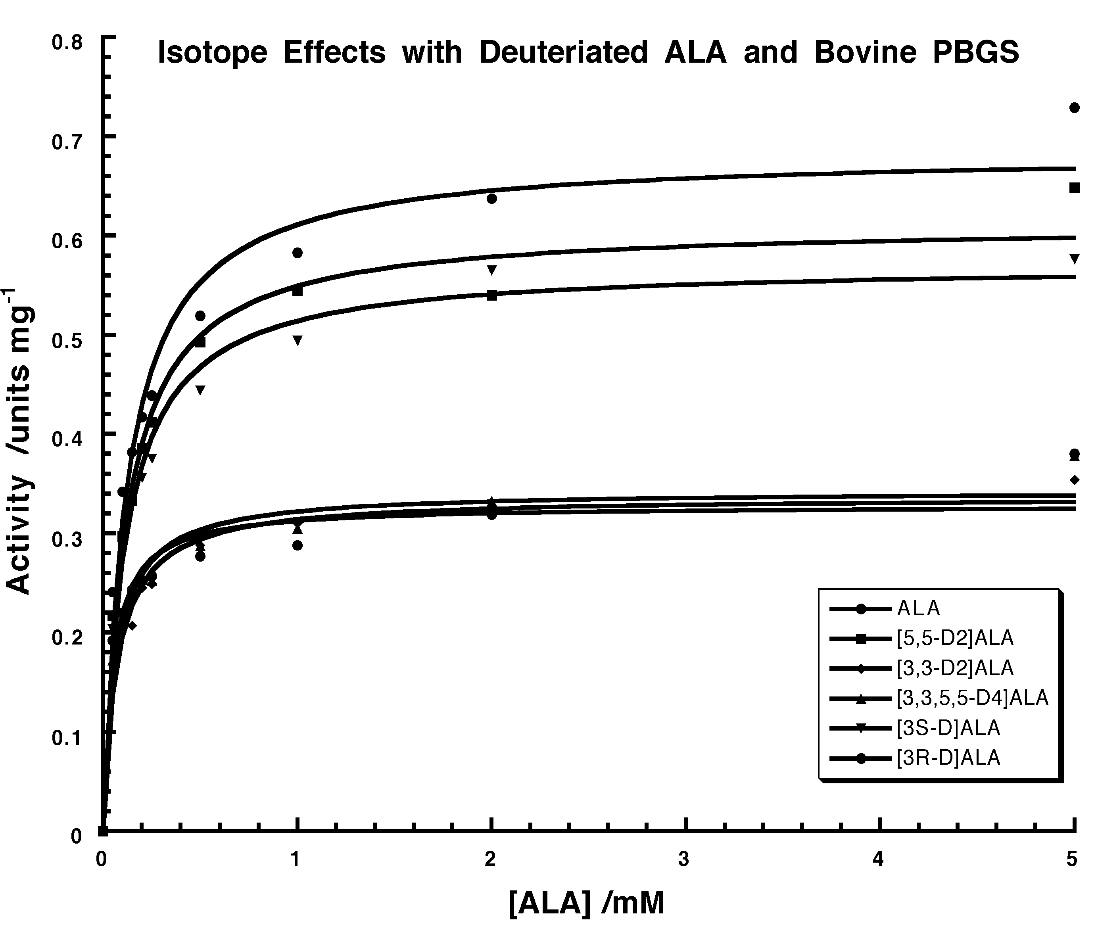

Supplementary Fig. 2

